Министерство образования Российской Федерации

Пензенский государственный университет

Кафедра «Вычислительная техника»

**ОТЧЕТ**

по лабораторной работе №2

по курсу «Программирование на языке Java»

на тему «Работа с коллекциями объектов»

Выполнили студенты группы 19ВВ3:

Табрисов С. А.

Литвинов А. Ю.

Приняли:

Юрова О. В.

**2022**

### Название

Графические интерфейсы

### Цель работы

Изучить библиотеку стандартных коллекций Java Collections Framework, позволяющую хранить различные структуры данных.

### Лабораторное задание

Таблица 1

|  |  |
| --- | --- |
| Вариант | Функция |
| 5 | $$e^{-x}$$ |

Модифицировать приложение из предыдущей лабораторной работы, реализовав хранение данных таблицы с использованием библиотеки коллекций. Для этого реализовать класс RecIntegral, способный хранить одну запись таблицы. Для нечетных вариантов в качестве класса-коллекции выбрать ArrayList, для четных - LinkedList. Кроме того, добавить пару кнопок: очистить / заполнить, которые будут очищать таблицу и заполнять ее данными из коллекции соответственно.

**Листинг**

**Файл RecIntegral.java**

public class RecIntegral {

double downValue;

double upValue;

double step;

public RecIntegral(double downValue, double upValue, double step){

this.downValue = downValue;

this.upValue = upValue;

this.step = step;

}

private double MathFuncExp(double x){

return Math.exp(-x);

}

public double IntegralFunc(){

int i;

double n, res = 0;

n=(upValue-downValue)/step;

res = step * (MathFuncExp(upValue) + MathFuncExp(downValue))/2.0;

for(i=1; i<n-1; i++){

res = res + step * MathFuncExp(downValue + step * i);

}

return res;

}

}

**Файл NewJFrame.java**

package com.mycompany.lab1;

import javax.swing.JOptionPane;

import javax.swing.table.DefaultTableModel;

import java.math.MathContext;

import java.util.ArrayList;

public class NewJFrame extends javax.swing.JFrame {

/**

* Creates new form NewJFrame

*/

public NewJFrame() {

initComponents();

}

/**

* This method is called from within the constructor to initialize the form.

* WARNING: Do NOT modify this code. The content of this method is always

* regenerated by the Form Editor.

*/

@SuppressWarnings("unchecked")

// <editor-fold defaultstate="collapsed" desc="Generated Code">

private void initComponents() {

jButton1 = new javax.swing.JButton();

jButton2 = new javax.swing.JButton();

jButton3 = new javax.swing.JButton();

jTextField1 = new javax.swing.JTextField();

jTextField2 = new javax.swing.JTextField();

jTextField3 = new javax.swing.JTextField();

jLabel4 = new javax.swing.JLabel();

jLabel5 = new javax.swing.JLabel();

jLabel6 = new javax.swing.JLabel();

jScrollPane1 = new javax.swing.JScrollPane();

jTable1 = new javax.swing.JTable();

jButton4 = new javax.swing.JButton();

jButton5 = new javax.swing.JButton();

setDefaultCloseOperation(javax.swing.WindowConstants.EXIT_ON_CLOSE);

setTitle("Интеграл ");

setBackground(new java.awt.Color(51, 204, 0));

setName("Интеграл "); // NOI18N

jButton1.setText("Добавить");

jButton1.addActionListener(new java.awt.event.ActionListener() {

public void actionPerformed(java.awt.event.ActionEvent evt) {

jButton1ActionPerformed(evt);

}

});

jButton2.setText("Удалить");

jButton2.addActionListener(new java.awt.event.ActionListener() {

public void actionPerformed(java.awt.event.ActionEvent evt) {

jButton2ActionPerformed(evt);

}

});

jButton3.setText("Вычислить");

jButton3.addActionListener(new java.awt.event.ActionListener() {

public void actionPerformed(java.awt.event.ActionEvent evt) {

jButton3ActionPerformed(evt);

}

});

jTextField1.setCursor(new java.awt.Cursor(java.awt.Cursor.TEXT_CURSOR));

jTextField1.addActionListener(new java.awt.event.ActionListener() {

public void actionPerformed(java.awt.event.ActionEvent evt) {

jTextField1ActionPerformed(evt);

}

});

jTextField2.addActionListener(new java.awt.event.ActionListener() {

public void actionPerformed(java.awt.event.ActionEvent evt) {

jTextField2ActionPerformed(evt);

}

});

jTextField3.addActionListener(new java.awt.event.ActionListener() {

public void actionPerformed(java.awt.event.ActionEvent evt) {

jTextField3ActionPerformed(evt);

}

});

jLabel4.setFont(new java.awt.Font("Serif", 0, 14)); // NOI18N

jLabel4.setText("Нижняя граница интегрирования");

jLabel5.setFont(new java.awt.Font("Serif", 0, 14)); // NOI18N

jLabel5.setText("Верхняя граница интегрирования");

jLabel6.setFont(new java.awt.Font("Serif", 0, 14)); // NOI18N

jLabel6.setText("Шаг интегрирования ");

jTable1.setFont(new java.awt.Font("Serif", 0, 12)); // NOI18N

jTable1.setModel(new javax.swing.table.DefaultTableModel(

new Object [][] {

{null, null, null, null},

{null, null, null, null},

{null, null, null, null},

{null, null, null, null}

},

new String [] {

"Нижняя граница ", "Верхняя граница", "Шаг", "Результат"

}

) {

boolean[] canEdit = new boolean [] {

true, true, true, false

};

public boolean isCellEditable(int rowIndex, int columnIndex) {

return canEdit [columnIndex];

}

});

jTable1.setColumnSelectionAllowed(true);

jTable1.setDoubleBuffered(true);

jTable1.setDropMode(javax.swing.DropMode.INSERT_ROWS);

jTable1.setGridColor(new java.awt.Color(228, 222, 222));

jTable1.setSelectionForeground(new java.awt.Color(204, 204, 204));

jTable1.setShowGrid(true);

jScrollPane1.setViewportView(jTable1);

jTable1.getColumnModel().getSelectionModel().setSelectionMode(javax.swing.ListSelectionModel.SINGLE_INTERVAL_SELECTION);

jButton4.setText("Очистить");

jButton4.addActionListener(new java.awt.event.ActionListener() {

public void actionPerformed(java.awt.event.ActionEvent evt) {

jButton4ActionPerformed(evt);

}

});

jButton5.setText("Заполнить");

jButton5.addActionListener(new java.awt.event.ActionListener() {

public void actionPerformed(java.awt.event.ActionEvent evt) {

jButton5ActionPerformed(evt);

}

});

javax.swing.GroupLayout layout = new javax.swing.GroupLayout(getContentPane());

getContentPane().setLayout(layout);

layout.setHorizontalGroup(

layout.createParallelGroup(javax.swing.GroupLayout.Alignment.LEADING)

.addGroup(layout.createSequentialGroup()

.addContainerGap()

.addGroup(layout.createParallelGroup(javax.swing.GroupLayout.Alignment.LEADING)

.addComponent(jScrollPane1, javax.swing.GroupLayout.Alignment.TRAILING, javax.swing.GroupLayout.PREFERRED_SIZE, 0, Short.MAX_VALUE)

.addGroup(javax.swing.GroupLayout.Alignment.TRAILING, layout.createSequentialGroup()

.addGroup(layout.createParallelGroup(javax.swing.GroupLayout.Alignment.TRAILING)

.addComponent(jLabel5, javax.swing.GroupLayout.DEFAULT_SIZE, javax.swing.GroupLayout.DEFAULT_SIZE, Short.MAX_VALUE)

.addComponent(jLabel4, javax.swing.GroupLayout.DEFAULT_SIZE, javax.swing.GroupLayout.DEFAULT_SIZE, Short.MAX_VALUE)

.addComponent(jLabel6, javax.swing.GroupLayout.DEFAULT_SIZE, javax.swing.GroupLayout.DEFAULT_SIZE, Short.MAX_VALUE))

.addGap(48, 48, 48)

.addGroup(layout.createParallelGroup(javax.swing.GroupLayout.Alignment.LEADING)

.addGroup(layout.createParallelGroup(javax.swing.GroupLayout.Alignment.LEADING, false)

.addComponent(jTextField2)

.addComponent(jTextField3, javax.swing.GroupLayout.PREFERRED_SIZE, 70, javax.swing.GroupLayout.PREFERRED_SIZE))

.addComponent(jTextField1, javax.swing.GroupLayout.PREFERRED_SIZE, 70, javax.swing.GroupLayout.PREFERRED_SIZE)))

.addGroup(layout.createSequentialGroup()

.addGroup(layout.createParallelGroup(javax.swing.GroupLayout.Alignment.TRAILING, false)

.addComponent(jButton4, javax.swing.GroupLayout.Alignment.LEADING, javax.swing.GroupLayout.DEFAULT_SIZE, javax.swing.GroupLayout.DEFAULT_SIZE, Short.MAX_VALUE)

.addComponent(jButton1, javax.swing.GroupLayout.Alignment.LEADING, javax.swing.GroupLayout.DEFAULT_SIZE, 93, Short.MAX_VALUE))

.addGap(26, 26, 26)

.addGroup(layout.createParallelGroup(javax.swing.GroupLayout.Alignment.LEADING, false)

.addComponent(jButton2, javax.swing.GroupLayout.DEFAULT_SIZE, 93, Short.MAX_VALUE)

.addComponent(jButton5, javax.swing.GroupLayout.DEFAULT_SIZE, javax.swing.GroupLayout.DEFAULT_SIZE, Short.MAX_VALUE))

.addPreferredGap(javax.swing.LayoutStyle.ComponentPlacement.RELATED, javax.swing.GroupLayout.DEFAULT_SIZE, Short.MAX_VALUE)

.addComponent(jButton3)))

.addContainerGap())

);

layout.setVerticalGroup(

layout.createParallelGroup(javax.swing.GroupLayout.Alignment.LEADING)

.addGroup(javax.swing.GroupLayout.Alignment.TRAILING, layout.createSequentialGroup()

.addContainerGap()

.addGroup(layout.createParallelGroup(javax.swing.GroupLayout.Alignment.BASELINE)

.addComponent(jTextField1, javax.swing.GroupLayout.PREFERRED_SIZE, javax.swing.GroupLayout.DEFAULT_SIZE, javax.swing.GroupLayout.PREFERRED_SIZE)

.addComponent(jLabel4))

.addPreferredGap(javax.swing.LayoutStyle.ComponentPlacement.UNRELATED)

.addGroup(layout.createParallelGroup(javax.swing.GroupLayout.Alignment.BASELINE)

.addComponent(jTextField2, javax.swing.GroupLayout.PREFERRED_SIZE, javax.swing.GroupLayout.DEFAULT_SIZE, javax.swing.GroupLayout.PREFERRED_SIZE)

.addComponent(jLabel5))

.addPreferredGap(javax.swing.LayoutStyle.ComponentPlacement.UNRELATED)

.addGroup(layout.createParallelGroup(javax.swing.GroupLayout.Alignment.BASELINE)

.addComponent(jTextField3, javax.swing.GroupLayout.PREFERRED_SIZE, javax.swing.GroupLayout.DEFAULT_SIZE, javax.swing.GroupLayout.PREFERRED_SIZE)

.addComponent(jLabel6))

.addGap(30, 30, 30)

.addComponent(jScrollPane1, javax.swing.GroupLayout.PREFERRED_SIZE, 93, javax.swing.GroupLayout.PREFERRED_SIZE)

.addGap(18, 18, 18)

.addGroup(layout.createParallelGroup(javax.swing.GroupLayout.Alignment.BASELINE)

.addComponent(jButton1)

.addComponent(jButton2, javax.swing.GroupLayout.DEFAULT_SIZE, javax.swing.GroupLayout.DEFAULT_SIZE, Short.MAX_VALUE)

.addComponent(jButton3))

.addGap(26, 26, 26)

.addGroup(layout.createParallelGroup(javax.swing.GroupLayout.Alignment.LEADING, false)

.addComponent(jButton5, javax.swing.GroupLayout.DEFAULT_SIZE, javax.swing.GroupLayout.DEFAULT_SIZE, Short.MAX_VALUE)

.addComponent(jButton4, javax.swing.GroupLayout.DEFAULT_SIZE, javax.swing.GroupLayout.DEFAULT_SIZE, Short.MAX_VALUE))

.addContainerGap())

);

pack();

}// </editor-fold>

public ArrayList array = new ArrayList();

private void jButton1ActionPerformed(java.awt.event.ActionEvent evt) {

// TODO add your handling code here:

double downValue;

double upValue;

double step;

try{

downValue = Double.parseDouble(jTextField1.getText());

upValue = Double.parseDouble(jTextField2.getText());

step = Double.parseDouble(jTextField3.getText());

RecIntegral recInt = new RecIntegral(downValue, upValue, step);

array.add(recInt);

DefaultTableModel table1 = (DefaultTableModel)jTable1.getModel();

table1.setRowCount(0);

array.forEach((s)->{RecIntegral rc = (RecIntegral)s; table1.addRow(new Object[]{rc.downValue, rc.upValue, rc.step});});

//table1.addRow(new Object[]{jTextField1.getText(), jTextField2.getText(), jTextField3.getText()});

// table1.insertRow(0, new Object[]{jTextField1.getText(), jTextField2.getText(), jTextField3.getText()});

// table1.setValueAt(new Object[]{jTextField1.getText(), jTextField2.getText(), jTextField3.getText()}, 0, 0);

}catch(NumberFormatException err){

JOptionPane.showMessageDialog(null, "Введите значения!");

}

jTextField1.setText("");

jTextField2.setText("");

jTextField3.setText("");

}

private void jButton2ActionPerformed(java.awt.event.ActionEvent evt) {

// TODO add your handling code here:

DefaultTableModel table1 = (DefaultTableModel)jTable1.getModel();

int selectRow = jTable1.getSelectedRow();

if (selectRow == -1){

JOptionPane.showMessageDialog(null, "Выберете строку!");

return;

}

array.remove(selectRow);

table1.removeRow(selectRow);

}

private void jButton3ActionPerformed(java.awt.event.ActionEvent evt) {

// TODO add your handling code here:

double downValue;

double upValue;

double step;

DefaultTableModel table1 = (DefaultTableModel)jTable1.getModel();

int selectRow = jTable1.getSelectedRow();

if (selectRow == -1){

JOptionPane.showMessageDialog(null, "Выберете строку!");

return;

}

downValue = Double.valueOf(table1.getValueAt(selectRow, 0).toString());

upValue = Double.valueOf(table1.getValueAt(selectRow, 1).toString());

step = Double.valueOf(table1.getValueAt(selectRow, 2).toString());

RecIntegral recInt = new RecIntegral(downValue, upValue, step);

double result = recInt.IntegralFunc();

//double result = IntegralFunc(downValue, upValue, step);

table1.setValueAt(result, selectRow, 3);

}

private double MathFuncExp(double x){

return Math.exp(-x);

}

private double IntegralFunc(double downValue, double upValue, double step){

int i;

double n, res = 0;

n=(upValue-downValue)/step;

res = step * (MathFuncExp(upValue) + MathFuncExp(downValue))/2.0;

for(i=1; i<n-1; i++){

res = res + step * MathFuncExp(downValue + step * i);

}

return res;

}

private void jTextField1ActionPerformed(java.awt.event.ActionEvent evt) {

// TODO add your handling code here:

}

private void jTextField3ActionPerformed(java.awt.event.ActionEvent evt) {

// TODO add your handling code here:

}

private void jTextField2ActionPerformed(java.awt.event.ActionEvent evt) {

// TODO add your handling code here:

}

private void jButton4ActionPerformed(java.awt.event.ActionEvent evt) {

// TODO add your handling code here:

DefaultTableModel table1 = (DefaultTableModel)jTable1.getModel();

table1.setRowCount(0);

}

private void jButton5ActionPerformed(java.awt.event.ActionEvent evt) {

// TODO add your handling code here:

DefaultTableModel table1 = (DefaultTableModel)jTable1.getModel();

table1.setRowCount(0);

array.forEach((s)->{RecIntegral rc = (RecIntegral)s; table1.addRow(new Object[]{rc.downValue, rc.upValue, rc.step});});

}

/**

* @param args the command line arguments

*/

public static void main(String args[]) {

/* Set the Nimbus look and feel */

//<editor-fold defaultstate="collapsed" desc=" Look and feel setting code (optional) ">

/* If Nimbus (introduced in Java SE 6) is not available, stay with the default look and feel.

* For details see http://download.oracle.com/javase/tutorial/uiswing/lookandfeel/plaf.html

*/

try {

for (javax.swing.UIManager.LookAndFeelInfo info : javax.swing.UIManager.getInstalledLookAndFeels()) {

if ("Nimbus".equals(info.getName())) {

javax.swing.UIManager.setLookAndFeel(info.getClassName());

break;

}

}

} catch (ClassNotFoundException ex) {

java.util.logging.Logger.getLogger(NewJFrame.class.getName()).log(java.util.logging.Level.SEVERE, null, ex);

} catch (InstantiationException ex) {

java.util.logging.Logger.getLogger(NewJFrame.class.getName()).log(java.util.logging.Level.SEVERE, null, ex);

} catch (IllegalAccessException ex) {

java.util.logging.Logger.getLogger(NewJFrame.class.getName()).log(java.util.logging.Level.SEVERE, null, ex);

} catch (javax.swing.UnsupportedLookAndFeelException ex) {

java.util.logging.Logger.getLogger(NewJFrame.class.getName()).log(java.util.logging.Level.SEVERE, null, ex);

}

//</editor-fold>

/* Create and display the form */

java.awt.EventQueue.invokeLater(new Runnable() {

public void run() {

new NewJFrame().setVisible(true);

}

});

}

// Variables declaration - do not modify

private javax.swing.JButton jButton1;

private javax.swing.JButton jButton2;

private javax.swing.JButton jButton3;

private javax.swing.JButton jButton4;

private javax.swing.JButton jButton5;

private javax.swing.JLabel jLabel4;

private javax.swing.JLabel jLabel5;

private javax.swing.JLabel jLabel6;

private javax.swing.JScrollPane jScrollPane1;

private javax.swing.JTable jTable1;

private javax.swing.JTextField jTextField1;

private javax.swing.JTextField jTextField2;

private javax.swing.JTextField jTextField3;

// End of variables declaration

}

**Результаты работы:**

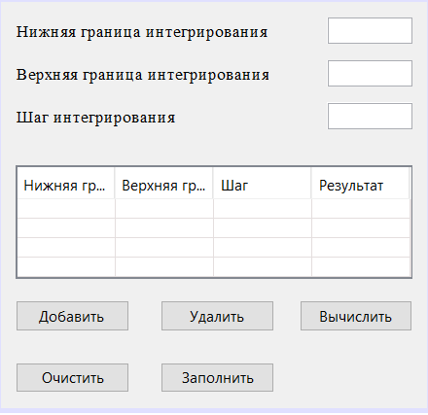

Рисунок 1 – Добавили кнопки.

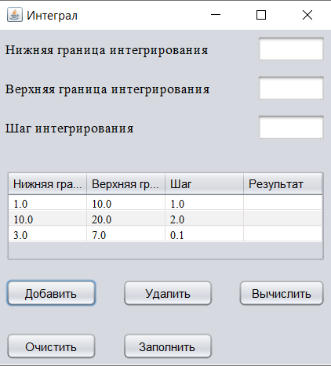

Рисунок 2 – Добавили значения в таблицу.

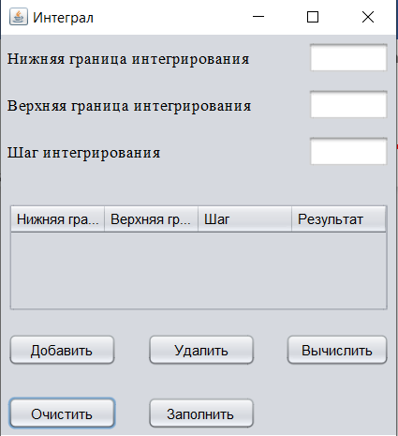

Рисунок 3 – Очистили таблицу.

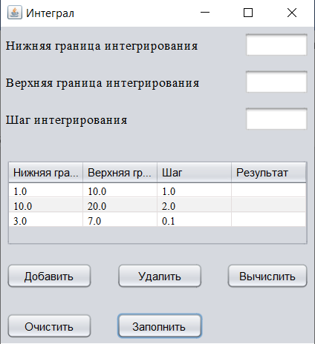

Рисунок 4 – Заполнили таблицу.

**Вывод:** Изучили библиотеку стандартных коллекций Java Collections Framework, позволяющую хранить различные структуры данных.